**Assignment 1 – C, C++ and Java Paradigms**

**Alexander Roan – alr16**

**Data Entry – Java**

The data entry program takes data from the user via command line interface and stores it directly into a file named with the new ship’s mmsi number in the ‘ships’ folder. It also writes the event and time of event to a log.txt file in a log folder. If these folder/files are not present when the program begins, they will be created by the program.

I’ve not included the printout of all 19 entries being input into the system because of the size of the document it would be in but here is a screen shot of the first being entered: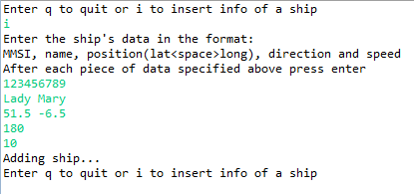

**Ship Finder – C**

The ship finder uses input from the command line to search for ships. It gives a choice whether to search using an mmsi number or a ship name. if the user decides to search using mmsi number, the program will simply attempt to open the file and read it. If the user decides to search using name the program loads in all the ships into a linked list, then traverses through it to find any names that contain the input that the user was looking for. It also writes which files were read to the log file

**Proximity Indicator – C++**

The proximity indicator continually re-loads the ship data from the files after each request just in case the Data Entry program changes anything. The program finds all of the ship mmsi’s from the file names, the loads each one into an array which is traversed when the user enters the query location. If there’s a match the ship(s) in question is printed out and a message is added to the log file about which file was read.

**Files**

There are 6 lines to a ship file. The first is the mmsi number (also the name of the file), the second is its name, 3rd is the latitude and longitude (in the format: LAT<space>LONG>), 4th is the direction, 5th is the speed and 6th is the date of entry (in the format: H:M:S.D/M/Y).